Employee Request Management

1. Project Title
Employee Request Management
(PowerApps + SharePoint + Power Automate)
2. Project Objective
The objective of this project is to create a centralized, automated system where employees can submit different types of requests such as:
- Leave Request
- Work From Home (WFH)
- Sick Leave
Once submitted, the request will be automatically sent to the manager for approval via Microsoft Power Automate.
The manager can Approve or Reject the request, and the updated status will reflect inside the app.
This solution improves:
- Request tracking
- Approval efficiency
- Transparency
- Time saving
- Automation
3. Tools and Technologies Used
Tool | Purpose
PowerApps | App UI, screens, forms, and logic
SharePoint | Backend data storage
Power Automate | Approval workflow
Notifications | Success/error alerts
4. System Architecture
PowerApps App
↓
SharePoint List (Employee Request, Employee Details, Master Role)
↓
Power Automate
↓
Manager Approval
↓
SharePoint Status Update

5. SharePoint List Structure
List Name: Employee Request
Column Name | Type | Description
Employee Name | Text | Logged in user
Employee Email | Text | Auto-captured using User().Email
Employee ID | Text | Captured ID
Request Type | Text | Leave / WFH / Sick Leave
Reason | Multiple lines | Reason for request
Start Date | Date | From date
End Date | Date | To date
Status | Text | Pending/ Approved / Rejected
Manager Email | Text | Auto-detected from Master Role List
Comments | Multiple lines | Manager response
Submitted On | Date | Autom

List Name: Employee Details
Column Name | Type | Description
Employee Name | Text | Logged in User
Employee Email | Text | Auto-captured using User().Email
Employee ID | Text | Captured Employee ID
Department | Text | Development/Testing/Technical Support
Direct Reporting Manager | Text | Auto-detected from Master Role List
Manager Email | Text | Auto-detected from Master Role List

List Name: Master Role
Column Name | Type | Description
Employee Name | Text | Name
Employee Email | Text | Mail ID
Employee ID | Text | Captured Employee ID
Department | Text | Development/Testing/Technical Support
Direct Reporting Manager | Text | Manager Name
Manager Email | Text | Manager mail ID
6. PowerApps App Screens
Home Screen
- Shows navigation buttons:
  - My Profile
  - Create New Request
  - My Approval
- Clean and simple UI
- Zoom-friendly responsive layout
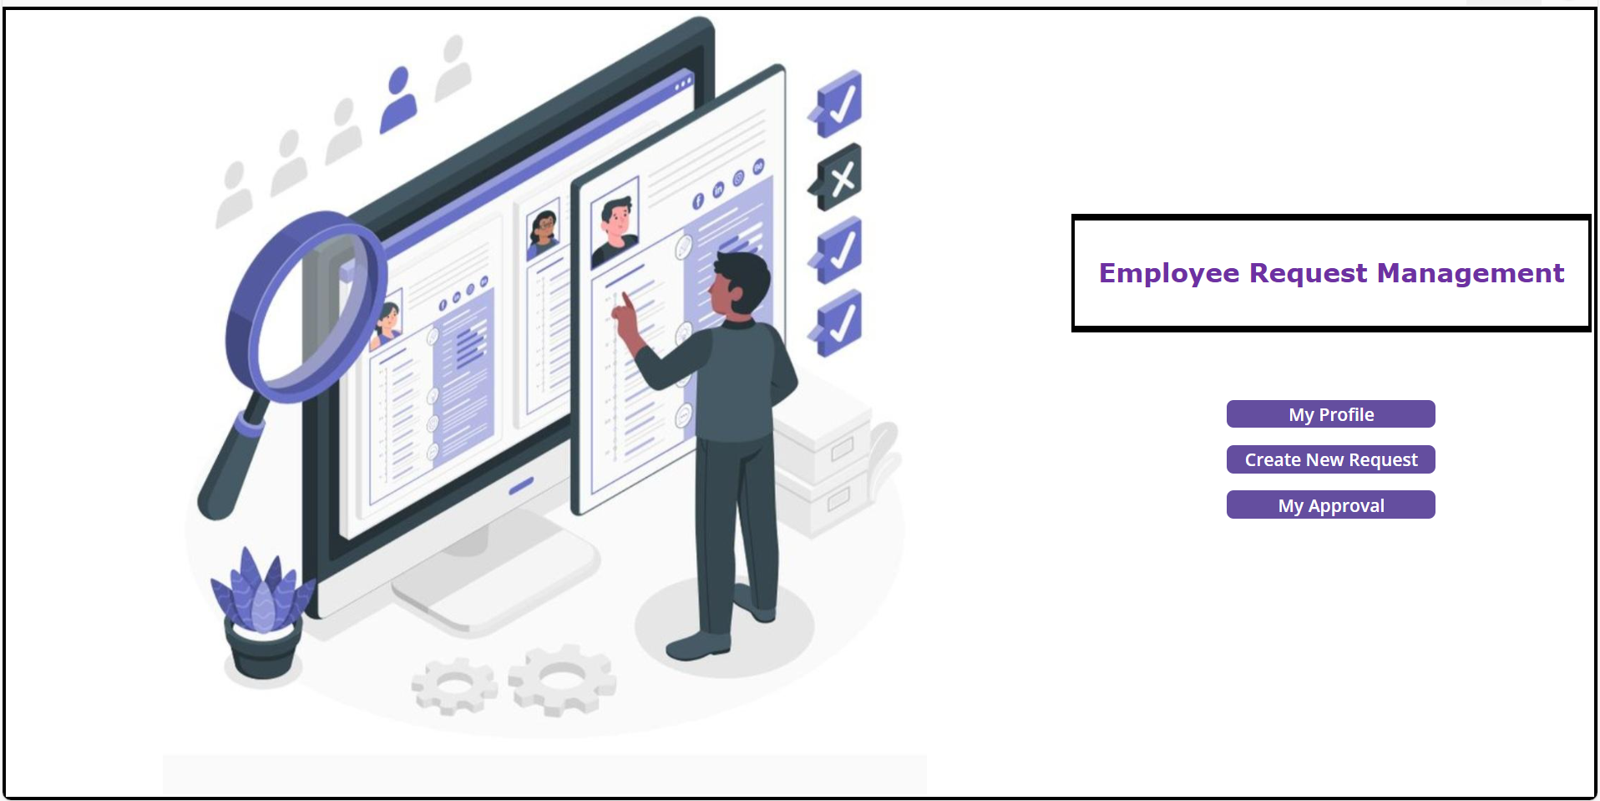
My Profile Screen
This screen displays employee personal details:
- Employee ID
- Name
- Email
- Department
- Direct Reporting Manager
My Request Table shows:
- Request Type
- Start Date
- End Date
- Total Days
- Status (Approved/Rejected/Submitted)
- Eye icon → view full details
This helps employees track all their submitted requests.
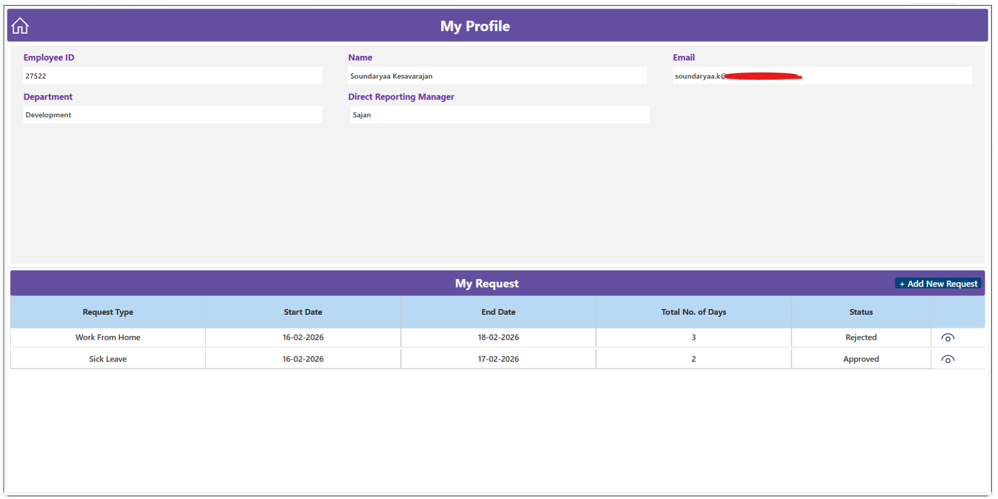
Create New Request Screen
- Employee selects:
  - Request type
  - Start & End dates
  - Reason
- Auto-filled:
  - Name
  - Email
  - Manager email
- Submit button triggers flow via SharePoint
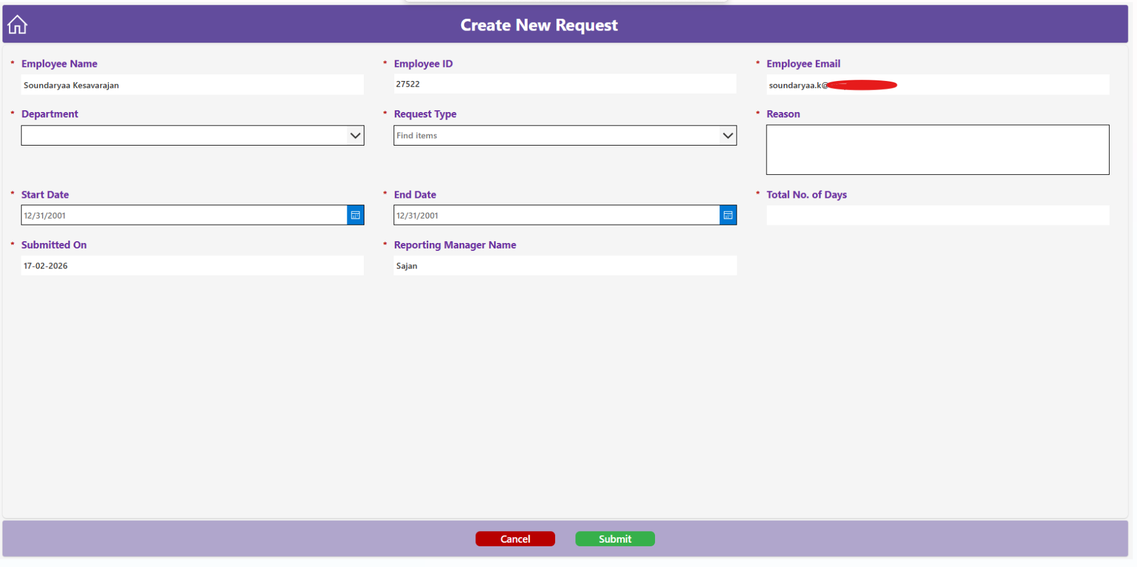
View Request Form
This screen shows the selected request in read-only format.
Fields displayed:
- Employee Name
- Employee ID
- Employee Email
- Department
- Request Type
- Reason
- Start/End Date
- Total No. of Days
- Reporting Manager
- Submitted On
Used for verifying details.
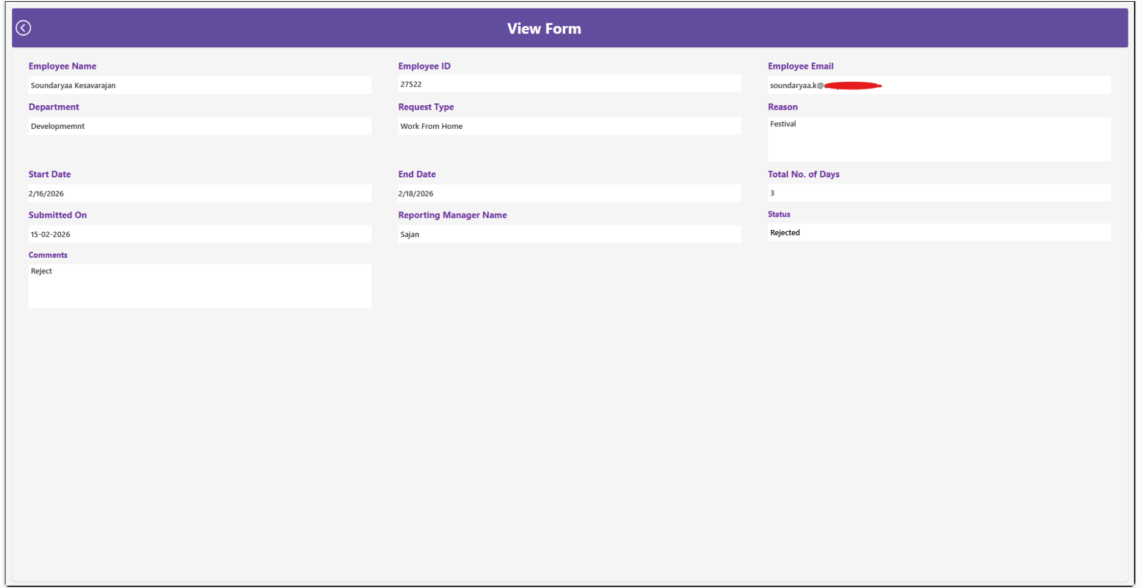
My Approval Screen
This screen is for managers/approvers.
Displayed fields:
- Employee Name
- Department
- Request Type
- Total No. of Days
- Submitted Date
- Status
Manager can click the eye icon → view full request → approve/reject via Power Automate.
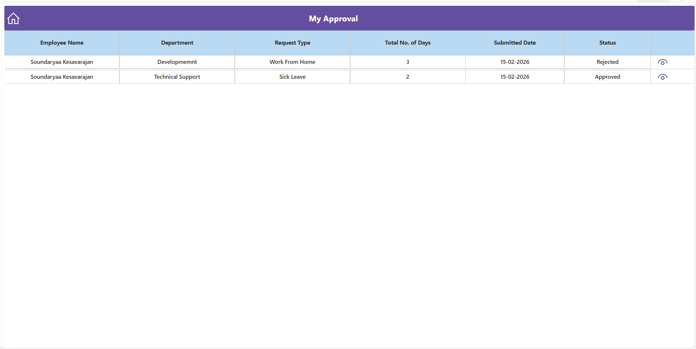
My Approval View Form
Shows the full request details in a view-only format for manager review.
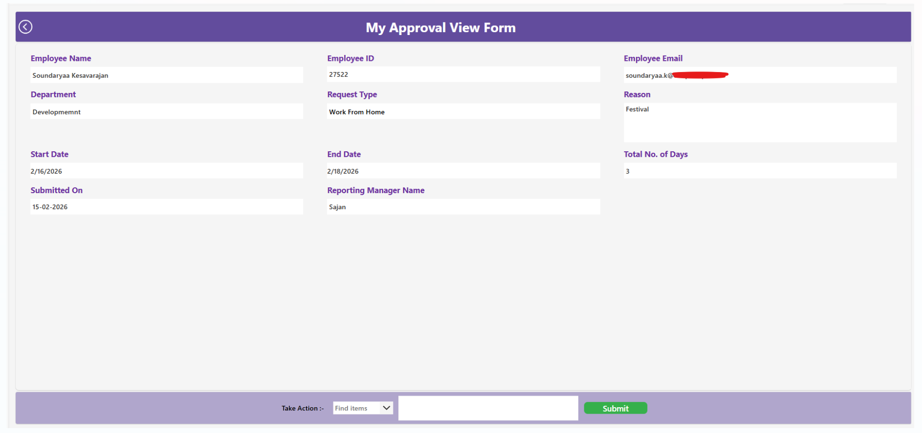
7. Power Automate Flow – Approval Workflow
Flow Steps
- Trigger: When a new item is created and Updated in Employee Request list
A new item is created
This happens when an employee submits a new request
Status = Pending
Flow sends two emails:
- Email 1 — To Employee
- Email 2 — To Manager

Item is updated
When manager approves or rejects
- Email — To Employee
- Condition:
  - If Approved → Update Status = Approved
  - If Rejected → Update Status = Rejected
- Update comments from manager in SharePoint
Flow Purpose
- Automates the entire approval cycle
- Removes manual follow-up
- Ensures quick response
- Stores all actions in SharePoint
8. Importing & Reusing This App
Import the App
- Go to https://make.powerapps.com
- Apps → Import canvas app
- Upload Employee Request Management.msapp
Import the Flow
- Go to https://make.powerautomate.com
- My flows → Import
- Upload EmployeeRequestApprovalFlow.zip file
Update Connections
You must reconnect:
- SharePoint site
- Flow connections
- User profile connector
Create your own SharePoint List
Use the same column names provided above.
9. Project Benefits
- No manual request tracking
- Faster approval process
- Accurate records
- User-friendly design
- Works on mobile & desktop
- Scalable for more features
10. Future Enhancements
- Multi-level approval (Manager → HR → Admin)
- Dashboard using Power BI
- PDF request receipt
- Attachments support
11. Conclusion
This Employee Request Management demonstrates the ability to design, build, and automate a real-world business process using PowerApps, SharePoint, and Power Automate.
The project shows understanding of:
- UI design
- Data modelling
- Automation flow
- User management
- Integration between Power Platform components
This solution is suitable for companies wanting a paperless approval process.

Thank You

Soundaryaa Kesavarajan
Junior Programmer
Power Platform Developer

